California Native Plant Society
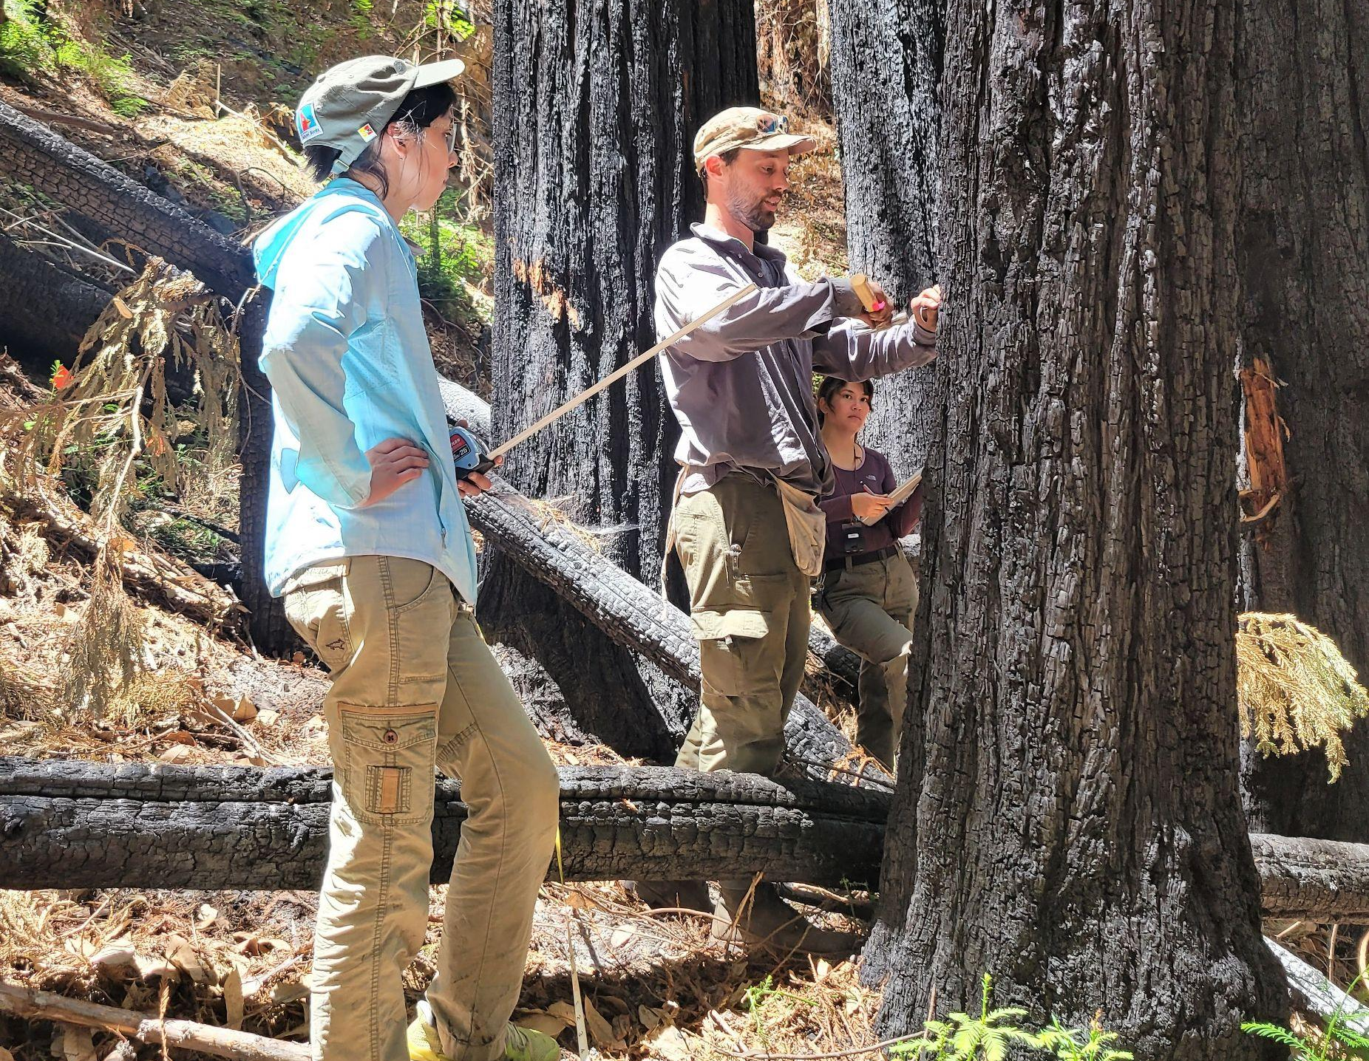
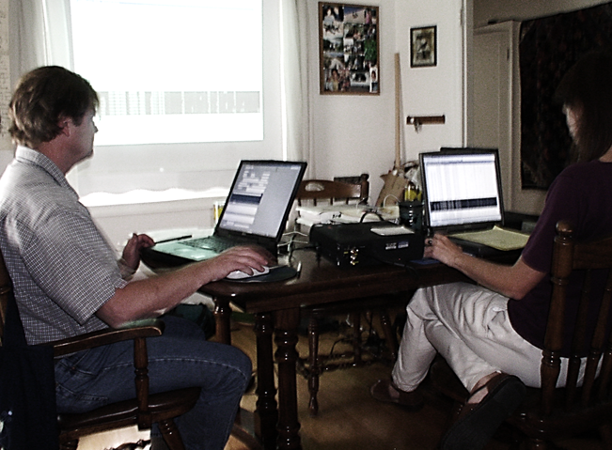

Organization/Agency: California Native Plant Society, Vegetation Program
Supervisor/Sponsor: Julie Evens Supervisor/Sponsor title: Vegetation Ecologist
Address: 2707 K Street, Suite 1, Sacramento, CA 95816 Email: jevens@cnps.org
Phone: (916) 447-2677 Website: www.cnps.org
# of interns needed/Hours Needed for quarters: Options (choose one)
worked per intern: Fall Winter Remove your listing by
3 to 4 / 2 or 5 units X Spring X Summer X Or keep on file for one year

Describe the internship assignment:

Interns will work remotely to a) summarize data collected within long-term monitoring plots in Redwood Forest communities in Santa Cruz Co. last year AND/OR assist in the field to b) help collect new post-fire vegetation data in San Mateo, Santa Cruz, and/or Santa Clara Cos. For the redwood forest monitoring project, 17 plots were installed and sampled by California Native Plant Society (CNPS) Staff, Volunteers and Students. Summary analyses will be based on the 7 paired plots including both Burned and Unburned Redwood Forests. Tasks will also include: helping with summarization and analysis the 2021 monitoring data, as well as submitting species photo data to iNaturalist, reporting and/or journal writing. For the post-fire vegetation sampling, interns will revisit redwood plots and conduct new surveys in various sensitive natural communities in the Central Coast that burned in the CZU, SCU or other fire complexes.

The California Native Plant Society (CNPS) is a statewide non-profit conservation organization (www.cnps.org) founded in 1965, with more than 10,000 members in 35 chapters across California and Baja California Mexico. The mission of CNPS is to increase understanding and appreciation of California’s native plants and to conserve them and their natural habitats through scientific study, education, advocacy, horticulture, and land stewardship. The CNPS Vegetation Program supports a uniform system for vegetation sampling, classification, and mapping and maintains vegetation information databases. This system, developed over the past 25 years by CNPS and the California Department of Fish and Wildlife (CDFW), is used by both governmental and non-governmental institutions to map, categorize and describe vegetation.

Vegetation mapping and ground-based sampling are useful tools for resource assessment, land management, regional planning, and long-term resource monitoring. Since San Mateo, Santa Cruz, Santa Clara, and Monterey Counties experienced an unprecedented wildfire season in 2020 as well as other fires in recent years (CalFire 2020), CNPS and partners have begun to set up an array of monitoring plots in redwood forests that span a two-dimensional gradient of burn intensity (from high intensity to unburned) and hydrology (from drier to wetter). By having numerous monitoring plots, land managers can better evaluate ecosystem biodiversity in redwood forests across a broad swath of Santa Cruz County and evaluate invasive plant threats, particularly in areas with recent fire or near development. This research can also provide further insight on fire risk, invasive plants, Sudden Oak Death Syndrome (SODS), and other impacts. Assessing ecosystem biodiversity and threats will directly assist land managers to prioritize restoration efforts across this region where habitat fragmentation, climate change, and other disturbances continue to occur.

For office/lab based interns we request: Availability to assist with data summarization, creation of figures, graphs or charts in GIS or in Excel, analysis of burned and unburned plots, and writing for a report or journal article in collaboration with CNPS and the FERP program. This indoor assistance needs to be completed in April and May.

Additionally, other post-fire vegetation plots are being established in forest, shrubland, and herbaceous vegetation types to survey the characteristics of burned vegetation and fire-followers on State Park (SP) lands such as Butano SP, Big Basin Redwoods SP, Henry Cowell Redwoods SP, and Henry Coe SP. The focus in 2022 will be to document trends in sensitive natural communities such as maritime chaparral, oak woodlands, cypress and pine woodlands, and other habitats that contain fire-followers. Interns will participate in field botany and vegetation surveys in natural areas, where participants will learn and practice survey methods used by the California Native Plant Society (CNPS), California Department of Fish and Wildlife (CDFW) and UCSC that include a post-fire focus. Photography and using GPS and smart mapping tools will be a part of the work (e.g. Ipads with ESRI Survey123, etc.). Participants will be required to help identify plant species, create short narrative descriptions of study areas, and collect detailed measurements of vegetation (e.g., percent cover by species, burn severity, etc.). All-day field trips to local wild areas will focus on plant communities and techniques involved in vegetation monitoring, mapping, and classification. Time frames will depend on the level of interest and availability for exploratory field trips and vegetation surveys.
For field based interns we request: Availability for at least one (1) full day each week would be ideal, particularly for field work – for full days, we are hoping those could be mostly in the timeframe of April to early June (if the spring quarter). Please fill out the online application indicating your availability. (For example: Tuesday or Wednesday all day (preferred), Tuesday morning, Tuesday afternoon)

All participants will follow public health instructions issued by local, state, and federal governments if performing field work, including but not limited to: social distancing, wearing masks, frequent hand washing, and avoiding the sharing of equipment.

Recommended Faculty Sponsor is Professor Gregory Gilbert, who is a collaborator on this project.

Prerequisites:
Outline the skills and background information necessary to participate in this internship.

- Attention to detail
- Basic knowledge about California floristics
- Enthusiasm about learning about different plants/vegetation, doing plant/vegetation research, data entry and quality control of data, and synthesis of information
- Basic understanding of field data collection techniques and Geographic Information Systems (GIS)
- Ability to analyze data, summarize vegetation patterns, and generate graphs or figures
- Experience in writing complete, descriptive sentences.

