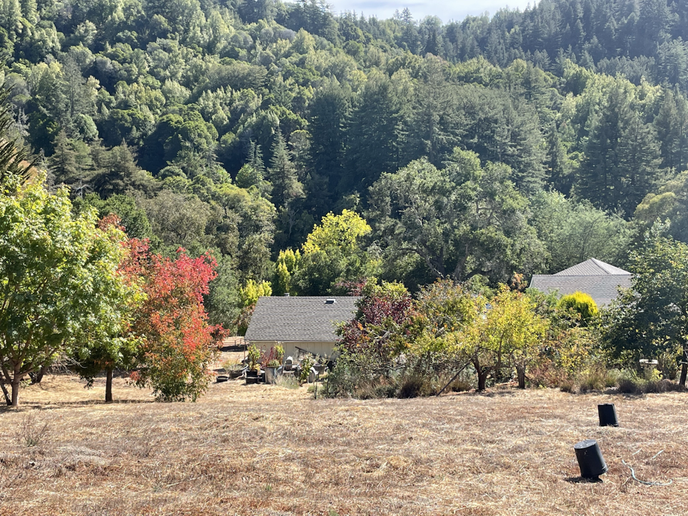

We are embarking on a project to restore the land, which is on the unceded territory of the Amah Mutsun tribal people, to as close to the way in which it was historically and ecologically for indigenous peoples/ancestors, pre-colonialism and indigenous genocide. In addition to
inviting UCSC student interns, we have been partnering with UCSC and Central Coast Wilds.
Interns would partner and collaborate with us on our sustainable Mother Earth project to assist in stewardship and restoration of our land by assisting in planting native plants, including indigenous sacred beauties of cultural significance. Project work and physical, hands-on activities may include the following: planting, maintenance, ground preparation, garden work, and invasive plant control.
- Student interns would work in teams and learn about how private landowners can and ought to be part of the solution to increase biodiversity on their lands.
- Stipend paid in spring quarter with possible summer work
- We are hoping that this internship will be fun, inspiring, and that it will help to spur similar actions in others. We would love to have you be a part of our collective vision to create a more healthy Earth for all people, our plant brethren, the winged, the finned, and the four-legged. We are open to any guidance, thoughts or suggestions from interns.
- ENVS Restoration 160 a plus!
- Bipoc peoples strongly urged to apply.
Introducing ourselves: We have been immersed in sustainability, environmental/social justice for 35+ years, as educators and through community and NGO work, climate/biodiversity
preservation, activism, and life choices. We are inspired by all things good on beautiful Planet Earth. We especially love people who do incredible and inspiring things to make this world a better place and stand up for justice, truth, liberty, happiness, and beauty for all.
We lived in our sustainable, solar, strawbale home for 20 years; worked actively with thousands of students; have an NGO/projects in Rwanda, Nicaragua, with the Lakota people, and in Watsonville with farmworkers. We would love to partner with you, as well as to continue our life’s work and further our mission to share the land and “be the change we wish to see in the world.”
Contact:
Mark (he, him) and Kristin (she, her) Sullivan
(831) 295-0005, kjsullivan@protonmail.com
Please call if you have questions, or just email your resume that incudes classes taken.
