Santa Cruz Predatory Bird Research Group Intern Opportunities
Overview: The Predatory Bird Research Group is a long-standing non-profit organization at UCSC tasked with monitoring wild populations of predatory birds and promoting their conservation through education and local involvement. Interns will learn to identify the breeding raptors of Santa Cruz County and gain hands-on skills in field observation and data collection. Participation in both Winter and Spring quarters is preferred: field observation training will take place in Winter Quarter (2 units), data collection and research activities will take place in Spring Quarter (2 or 5 units). Leadership roles and independent research opportunities are available to students able to take the 5 unit internship in Spring Quarter.
Winter Training for Raptor Research Internship: (2 units – 6 hours/week)
Learn to identify raptor species in the field and to take detailed notes of behavior and
location. Students will conduct raptor nest location groundwork for spring quarter research projects. This training portion includes 4 hours of classroom learning at the Ken Norris Center, and 4 hours of group field instruction, before independent observations begin. Students are required to write-up weekly reports of their observations. Observation sites located on-campus and/or off-campus based on student’s access to a vehicle.
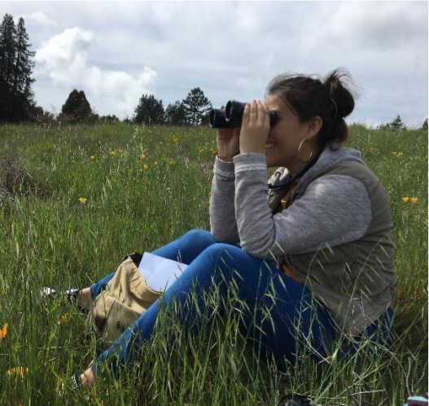
Winter Continuing Raptor Research Internship: (2 units – 6 hours/week, 5 units – 12 hours/week) For students that have previously participated in the Winter Training Internship or have relevant field research experience. Students will participate in a Santa Cruz County raptor-recruitment project as well as continuing data collection on Great Horned Owl and White-tailed Kite breeding observations. Opportunities exist on a student-by-student basis for independent research projects.
Spring Raptor Research Internship: (2 units – 6 hours/week, 5 units – 12 hours/week) Students will participate in a Barn Owl recruitment and breeding study as well as continuing data collection on Great Horned Owl and White-tailed Kite breeding observations. Student interns will also mentor high school students assisting with data collection. Opportunities exist on a student-by-student basis for independent research projects. Observation sites located on-campus and/or off-campus based on student’s access to a vehicle. Mileage will be reimbursed.
Prerequisites: We seek students that are self-motivated and willing to work independently. Participation in the winter quarter Rachel Carson College class, “Peregrine Falcon Recovery—A Case Study in Conservation Success” (RCSN 20G) is strongly advised and class participants will have priority for internships. Experience with field identification of birds or completion of BIOE 112 or ENVS 106A preferred, however training will be available to less experienced students.
Contact: Director Zeka Glucs, zekaglucs@ucsc.edu

