Ecology Action

Bike and Walk Smart Internship
www.bikesmart.org

Gain experience in public speaking, youth education, classroom management, sustainable transportation, and more through Ecology Action’s Bike and Walk Smart Internship.

Position: Bike and Walk Smart Intern
Status: Part-time, unpaid, must be for academic credit
Location: Santa Cruz & Monterey County
Schedule: 1-2 days (5-15 hours) per week; minimum of 5 weeks commitment. Candidates must be available 1-3 weekdays from 7:30 am to 12:30 pm or from 7:30 am to 3 pm.

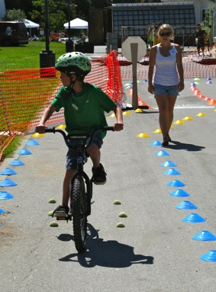
Bike and Walk Smart interns assist lead staff in implementation of youth bicycle and walk safety trainings and program development projects.

Children love the freedom, motion, and exhilaration of riding their bikes or walking.
Our programs provide engaging, interactive, and hands-on youth bike safety and walk safety education, which gives children the needed knowledge, skill, and practice to be safe cyclists and pedestrians.
More students walking, biking, skating or scooting to school means fewer cars around school neighborhoods. Less car congestion results in decreased greenhouse gas emissions and safer routes for students.

Responsibilities:

- Assist with instruction of youth in bike and pedestrian safety trainings (bike skills obstacle courses)
- Assist with in-classroom presentations
- Program development projects (curriculum development, educational materials, etc.)
- Set up and break down obstacle courses
- Prepare materials for and assist with classroom presentations
- Grade presentation pre- and post-question sheets and maintain records
- Assist with advertisement and promotion of events
- Provide office administrative assistance

Requirements:

- Ability to work a minimum of 1 day per week, from 7:30am until 12:30pm
- Minimum 18 years old
- Background check required
- Ability to work collaboratively with other team members
- Punctual
- Excellent oral and written communication skills
- Highly organized and detail oriented
- Interest in working with and/or teaching youth
- Interest in promoting sustainable or active transportation
- Competence in Microsoft Word and Excel, web browsers, email
Desired Qualifications:

- Experience working in environmental public education and/or with youth
- Competence in graphics programs
- Bilingual Spanish language speaking skills
Physical Demands:

The physical demands described here are representative of those that must be met by an intern to successfully perform the essential functions of this job. Reasonable accommodations may be made to enable individuals with disabilities to perform the essential functions.
While performing the duties of this job, the intern will walk outdoors on school grounds for a significant portion of the day. The intern will regularly be required to sit, stand, walk up and down stairs, talk and hear, and use a computer. Will regularly be required to lift and move up to 25 pounds.

Work Environment: Outdoors on school grounds in Santa Cruz or Monterey County or in our Santa Cruz or Salinas office.

More About Us

Ecology Action is an award-winning non-profit organization that provides innovative solutions to the energy, water, and transportation challenges of cities, governments, and utilities across California. We have almost five decades of experience helping people make simple yet profound changes that have big environmental impact. We believe that when individuals and businesses make simple changes in their behavior, they drive large scale changes that benefit people and the planet. This translates into reduced carbon emissions, stronger businesses, healthier communities and a sustainable future for all. Together, we help people, businesses and communities act now.

Ecology Action is an Equal Opportunity Employer committed to diversity in its workforce. Candidates for this position must be currently a student.
Ecology Action does not offer a company paid relocation program.
Compensation: This is an unpaid internship. Interns must receive academic course credit.

To apply, please fill out the online volunteer and intern application:
https://ecoact.org/volunteer#volunteer-form

