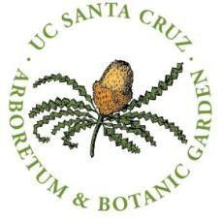 | Arboretum Interactive Ecology Internship Agency Sponsor: Brett Hall brett@ucsc.edu (831) 212-4853

UC Santa Cruz Arboretum Interactive Ecology interns will work primarily in the California Conservation Gardens, nurseries areas, greenhouses and with the Conservation seed bank in the UC Santa Cruz Arboretum. Botanical and horticultural skills training include:
Keying and plant ID
Seed processing for our seed bank
Transplanting, planting, pruning and gardening skills
Invasive weed control
Introduction to applied topics in biodiversity conservation (vegetation mapping, rare natural communities and land stewardship using the Arboretum as the example of an urban/semi wild ecologically rich series of habitats.

The internship is a 5 Unit upper or lower division ENVS course or 2 unit internship. 5 Units requires 12 hours per week (120 per quarter). 2 unit internships are 6 hours per week or 60 hours per quarter. Additional reading and other assignments will be part of the internship. In addition to touring the Arboretum and learning about the collections, we will make short field trips on campus and nearby as scheduling allows to look at different vegetation types.

Participants generally start at 8 am and work in teams
.

Contact Brett Hall, California Native Plant Program Director, for more information and to set up an interview. (831) 212-4853; brett@ucsc.edu.

The California Conservation Garden component of the course will consist of:

- Trail work
- Brush removal
- Weeding, especially invasive weeds
- Nursery work—transplanting, seed treatments and planting, asexual propagation of collections with cuttings and divisions
- landscaping and planting
- preparing lists of species and associations to fit geographic, ecological and horticultural themes identified in the conceptual plan for the gardens.

