SEASONAL BIOLOGIST JOB ANNOUNCEMENT
Spartina Treatment Monitor
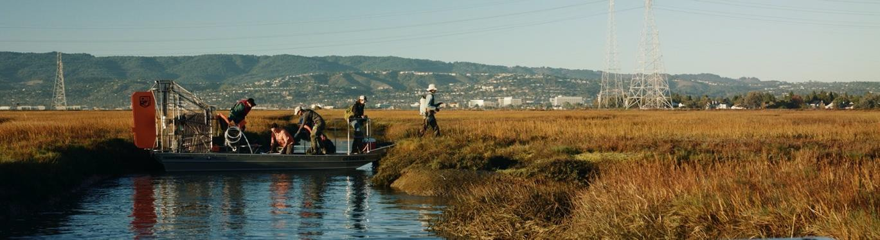

JOB DESCRIPTION
Olofson Environmental, Inc. (OEI) is an environmental consulting firm located in Oakland, California. OEI manages the San Francisco Estuary Invasive Spartina Project (ISP), a coordinated regional effort between local, state, and federal organizations dedicated to preserving California's extraordinary coastal biological resources through the elimination of non-native Spartina (cordgrass). ISP is seeking Spartina Treatment Monitors to assist with field monitoring of Spartina treatment activities as well as native marsh plant restoration plots.

Spartina Treatment Monitors will be trained in the following:
- Identification of native and invasive Spartina species and their hybrids
- Mobile GIS software to map Spartina in the field
- Desktop-based ArcGIS to edit field-collected data
- Safe use and application of herbicide

Spartina Treatment Monitor responsibilities will include:
- Using GPS units to relocate and record the treatment of invasive Spartina patches previously mapped by ISP biologists
- Leading contractor crews to invasive Spartina patches and monitoring herbicide application
- Mapping invasive Spartina
- Survivorship and photopoint monitoring of native marsh plant restoration plots
- Applying herbicide under direction of a licensed professional
- Environmental monitoring for construction projects (as needed – water sample collection and analysis training provided)
Work will begin July 11 and will continue through mid to late November. Position averages 30 to 35 hours/week. Hours will vary during the field season depending on tides, weather, and treatment schedule; some weeks may have little to no work and other weeks may require >40 hours. Work may start as early as 5 a.m. and end as late as 9 p.m.

QUALIFICATIONS

Required Qualifications:
- Coursework in ecology, conservation, habitat restoration, or a related field
- Some familiarity with plant identification, GPS, and/or computer-based mapping, and the ability to apply these skills independently after approximately two weeks of training
- Ability to work well independently and in a team setting
- Ability to follow project-specific field protocols and data entry/editing procedures
- Ability to communicate clearly and effectively
- Strong map-reading skills

Desired Qualifications:
- Undergraduate degree in ecology, conservation, habitat restoration, or a related field
- Experience with construction project work, supervision, and/or biological monitoring
- Boating and trailering a boat
- Motor vehicle maintenance
- A familiarity with the San Francisco Bay area or the ability to quickly orient themselves to the site locations and driving conditions

PHYSICAL REQUIREMENTS
Candidates must be willing and able to:
- Spend long periods of time in potentially adverse field conditions
- Walk 8+ hours per day outside in mud and soft substrate, in fully exposed sun, while carrying heavy equipment
- Comfortably lift and carry at least 30 pounds
- Conduct field surveys during and directly adjacent to application of imazapyr herbicide (trade name: Habitat or Polaris)
- Carry an herbicide backpack sprayer that weighs 30 pounds
- Swim, and be comfortable on and around boats (a majority of the remote field sites are accessed via watercraft)
- Get muddy!

OTHER REQUIREMENTS
- Available to work up to 5 full (8-10 hour) days a week, with the understanding that work availability will vary based on schedule and weather conditions
- Flexible and adaptable to changes in schedules and hours, often with very little advance notice
- Available for occasional Saturday work
- Must have use of a car and be able to travel to the Oakland office and to field sites around the San Francisco Bay (mileage to field sites is reimbursed; driver’s license and proof of automobile insurance are required)
- Must provide their own standard field gear, such as suitable clothing, backpack, and sun protection. Hip waders are required but can be borrowed if needed. ISP will provide technical gear, such as data collection units, range finders, compasses, and personal protective equipment (PPE)
- Work areas are in sensitive tidal marshes that may be inhabited by threatened or endangered species. Must demonstrate ability to follow protocols and show sensitivity to the habitat after one week of training

HOURS & PAY RATE
Hours are variable from 0 to 60 hours/week based on project needs, but typically average 30-35 hours/week. Pay rate is $17-$21/hour based on experience, with overtime paid at time-and-a-half, double time on weekends. Candidates will have access to all mandated federal, state, and local benefits. Pay rate would increase if employees return for future ISP seasons.

APPLICATION & IMPORTANT DATES
To apply, e-mail a cover letter, resume, and contact information for three professional references by

Friday, May 27 to:
Email: jobinfo@spartina.org Specify “Spartina Treatment Monitor Application” in the email subject line and address the cover letter to Ms. Melanie Anderson
Incomplete applications will not be accepted. Questions regarding this position should be directed to jobinfo@spartina.org. Interviews will be scheduled as qualified applications are received; applications will be reviewed until the positions are filled.

*INFORMATION REGARDING CORONAVIRUS PANDEMIC* *Updated 3/22/2022*

Position start date and duties are contingent on guidelines and orders issued by public health officials during the COVID-19 pandemic
- To carry out the work while protecting staff, ISP has developed and implemented best management practices that follow or exceed the guidelines of public health officials
- Because we frequently work and travel in close proximity to other OEI staff and subcontractors, all OEI field staff must be fully vaccinated with up-to-date boosters before beginning work

