PAID research opportunity in urban agroecology and insect ecology – WINTER 2022

Urban gardens are productive, diverse agroecosystems that provide 15-20% of the global food supply and promote gardener well-being. Gardeners share food production and nutritional and cultural services as primary reasons for gardening, but ecologists lack information about how to optimize ecological interactions within gardens that support these services. Ecosystem services, such as pest control of garden pests and pollination of garden crops, improve food production. In turn, provisioning of ecosystem services is determined by abundance, diversity, and functional traits (e.g., body size, hunting strategy, foraging location) of the insects in gardens. The goal of the research project in the Philpott (ANTS) Lab in the Environmental Studies Department is to examine linkages between urban garden management, socio-economic characteristics of gardens, and ecological interactions that promote pest control, pollination, and food production in gardens. Specifically, we aim to determine how local garden management and landscape changes, as well as socio-economic variables influence (a) functional traits of plants, pollinators, and natural enemies, (b) ecological networks, and (c) pest control, pollination, and crop production services. More information about our garden research can be found here. More research about the Building Belonging program can be found here.

In this research opportunity, students will be introduced to urban agroecology, learn insect identification skills, and will identify specific research questions that they would like to address with our data (e.g., How does land tenure of gardens influence bee diversity? Do gardens with more diverse flower communities support better biological pest control?). Details:
- The position is open to EOP students and veterans, first-gen students, etc.
- Students are expected to dedicate 100 hr during winter 2021 and will receive $1500 as a scholarship payment
- Students may register for 2 units of ENVS 199F – Independent Study to get academic credit in Winter
- There may be a possibility for continuing in spring and summer 2022
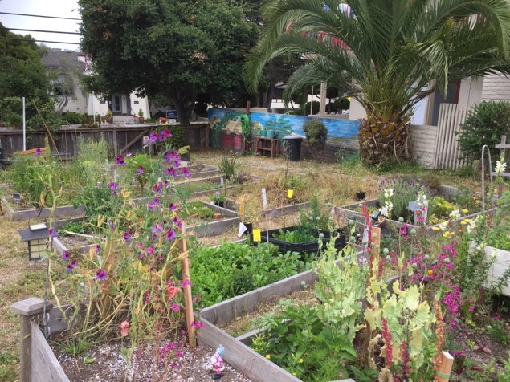
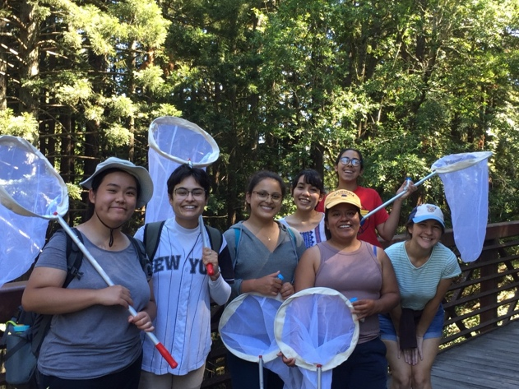
- To apply, please send a resume, an unofficial transcript, and a short letter (1-2 paragraphs) explaining your interest to Stacy Philpott (sphilpot@ucsc.edu) by Dec. 14.

