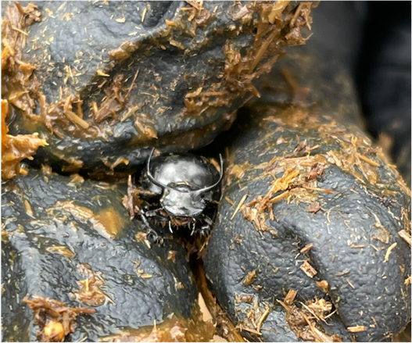
Spring 2022 Dung Beetle Internship

Background:
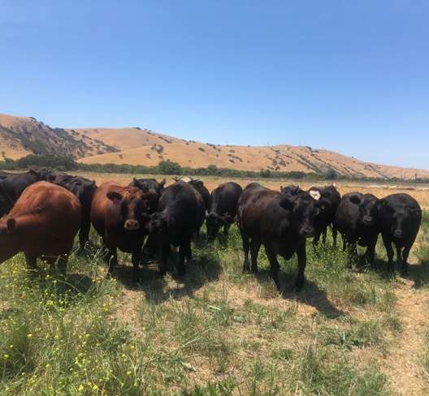
This project investigates the effect of grazing management and the surrounding landscape on dung beetle abundance and diversity on ranches in the Central Coast region of California and the effects of dung beetle diversity on soil microbial composition and soil organic carbon content in soils in these same ranches. The field work involves monitoring dung beetle populations by setting traps and assessing dung beetle abundance and diversity at ranches in the Central Coast region (around Santa Cruz). The project also involves a two-month experiment that will take place in the spring, in which I will monitor soil microbial composition and soil organic carbon content in constructed enclosures with varying dung beetle species compositions.

Field Work Description/Intern Duties:
Intern duties include setting traps and collecting/counting dung beetles caught in the traps. Traps are set at a ranch one day and collected two days later; this process is repeated across several ranches. The first days is spent collecting cow dung and setting traps baited with cow dung across 3-4 fields at a ranch. The second day is spent at the same ranch collecting dung beetles and assessing diversity and abundance across traps. All ranches are within approximately one hour’s driving distance of Santa Cruz and interns can get a ride with the project lead (Suzanne Lipton) from Santa Cruz. Interns will also help to set up enclosures for the two-month monitoring experiment and take first samples.

Interns must be comfortable walking around for a full day outside in grassy fields with sunshine, handling cow dung (with gloves or a shovel), and being around cows, sheep, turkeys, pigs and cute-but-sometimes-large ranch dogs. Interns must be able to pack and carry their own food and water for the day.

Time requirements:
Interns will need to have at least one full day available to come into the field—either Monday, Wednesday, or Friday/one day of the weekend. If an intern is enrolled for a 2-credit internship, they could fulfill their hours by coming into the field for one day of the week. If the intern is enrolled for a 5-credit internship, they could fulfill their hours by coming into the field for two days of the week. We will spend approximately 6 hours in the field on collection days and 4 hours on setting days, with an hour drive on each end of the day. Some days may be shorter or longer—field work is sometimes unpredictable!

It is also possible to continue this work during the summer for a second sampling season, and soil analysis. Contact Suzanne Lipton for more details: suzannelipton@ucsc.edu

