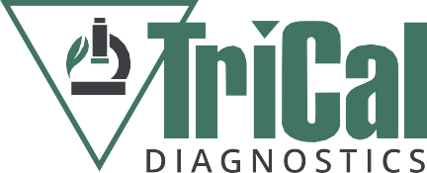
TriCal Diagnostics Summer Lab Assistant Position 2022

Who we are:
We are a full service plant diagnostics lab located at 8770 Highway 25 in Hollister, CA. We use traditional (culturing and microscopy) and molecular methods to diagnose all types of plant pathogens including fungi, bacteria, viruses, and nematodes. Our samples include plants, soil, and water from small and large farming operations across the United States, with most of our samples coming from California. Common samples include lettuce and strawberry. For more information, see our website at tricaldiagnostics.com.

Who you are:
We are looking for a summer intern who possess the following traits:
- Organized
- Dependable
- Able to multi-task and manage time well
- Detail-oriented
- Enthusiastic and eager to learn
- Strong communication and teamwork skills
- Background in science or agriculture is preferred

Responsibilities and Expectations:
As a summer intern at TriCal Diagnostics, you will do the following:
- Prepare plant samples for testing (washing, dissecting, processing)
- Conduct plant isolations for pathogens
- Assist with molecular diagnostics (DNA extractions, PCR, etc.)
- Prepare microbiological media and other lab materials
- Plant, water, fertilize, and maintain plants for experiments
- Wash lab glassware and maintain the cleanliness of the lab and greenhouse
- Help with field experiments
- Assist with projects, record-keeping, and paperwork
- Adhere to lab safety and COVID policies

Anticipated Work Hours:
This is an hourly paid position with a maximum 3-month appointment. The regular work schedule is Mon. to Fri., 8:30 am to 5:30 pm. There are no benefits available for this position. Start date and weekly working hours are negotiable.

To apply, send cover letter and resume to:
Steven Koike, skoike@trical.com, 408-612-6729

